Pong SFML – Tutorial 05

Specification
- ASSESSED Use overloading and inheritance to create Pong – an early class videogame hit.
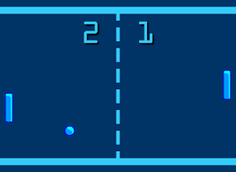
- SFML contains a class called Vector2f, you will create your own version called Vec2f to represent x/y coordinates – you started this last time. Anything involving positioning an image on the screen or moving an image should use a Vec2f. Add conversion constructors so you can easily move between this type and those in SFML when necessary. Override common operators so Vec2f can be used in an elegant way (+, +=, *, etc.) add useful behaviours.
- Create a super class GameObject, anything with a position is a candidate for a game object: ball, player1 bat, player2 bat, court, p1score, p2score, topWall, bottomWall. What behaviour and/or state is common to all/some of these objects?
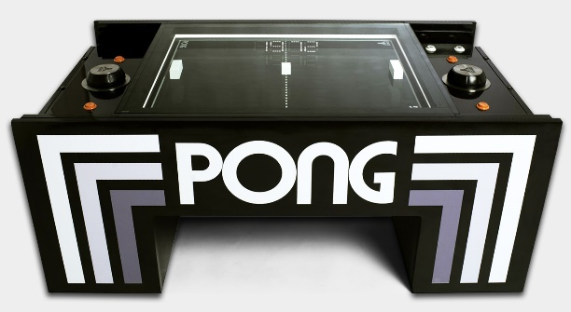
- Spec: find or make sprites for: court, bat, ball. Find a font to use. Look up some information about Pong, look at some video of the game in action, it’s very simple. Get the basic game working:
  - Render the court
  - Paddles move up and down using the keyboard (player1 W/S and player2 Up/Down), but stop at the walls.
  - The ball is attached to player1’s bat initially and moves with it until that player starts the game by pressing any other key. In future turns the starting player alternates. Firing near the top half of the screen angles the ball upwards, in the lower half it angles the ball’s path downwards. The game doesn’t end.
  - After being fired the ball moves in a straight line. If it hits the wall, then it bounces off (invert Y component of velocity).
  - If it hits the bat it bounces off (invert X component of velocity) – there is a way to modify this behaviour to give the player more control, see below, but that’s optional.
- Evidence the usual game design, technical design, test plan, GiT log and solution.
Competencies: 1.1,1.2,1.3,1.4,1.5,1.6,1.7,1.8.3,1.8.4,1.8.6,1.8.7,1.8.8,1.8.9,1.9,1.10.2,2.1,2.2,2.3,2.4

Game Design
Overview
Two players control one bat each and hit a ball towards each other until one of them wins.
Rules
There are two players
The first player to 6 wins
The game ends after 11 rounds
Gameplay
There is a simple start menu where the players can choose to either play or exit
Player 1 moves the left bat by using the W and S keys
Player 2 move the right bat by using the up and down arrow keys
The ball bounces off the walls and the players bats
If a player does not manage to hit the ball, the other play scores a point
At the end of the game there is a game over screen where the players can either quite or play again

Technical Design
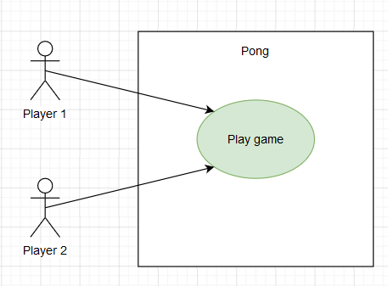
The players want to play the game of pong
- Player 1 or player 2 selects start using the arrow keys and presses enter to start the game
- Player 1 controls the left bat by pressing the W and S keys
- Player 2 controls the right bat by pressing the up and down arrow keys
- Player 1 presses space to release the ball from Player 1s bat to begin playing
- Player 1 and player 2 press space to release the ball on alternating rounds
- The system makes the ball start on alternating player bats
- The system checks for collision on the ball and walls
- The system checks for collision on the ball and bats
- The system checks if the ball has passed either player 1 or player2s bat and increases the score of the opposite player
- The system checks if a player has a score of 6 and ends the game if a player has
- The system checks if 11 rounds have been played and ends the game is there has
- The system then shows the game over screen and shows the final score

*Also see class diagrams found in the same directory as this document

Test Plan
State | Expected | Actual
Menu | Player uses arrow keys or S and W keys to select menu option | OK
Menu | Player presses enter to play the game | OK
Menu | Player presses enter to exit the application | OK
Game | Player 1 presses W and S to move the left bat up and down | OK
Game | Player 2 presses the up and down arrow keys to more the right bat up and down | OK
Game | The ball alternates on which player to start on for each round | OK
Game | Alternating player 1 and player 2 presses space to release the ball and start the round | OK
Game | The ball collides with the bats and bounces off them | OK
Game | The ball collides with the walls and bounce off them | OK
Game | The ball bounces off upwards if it collides with the top half a player’s bat | OK
Game | The ball bounces off downwards if it collides with the bottom half a player’s bat | OK
Game | The ball moves past player 1s bat and the score of player 2 increases and the next round starts | OK
Game | The ball moves past player 2s bat and the score of player 1 increases and the next round starts | OK
Game | When a player has a score of 6 the game ends | OK
Game | When 11 rounds have been played the game ends | OK
Game over | The player that wins is displayed on screen | OK
Game over | Player uses arrow keys or S and W keys to select menu option | OK
Game over | Player presses enter to start the game again | OK
Game over | Player presses enter to exit the application | OK

Git commit log
